Contacts and other valuable information
If you are not already a member of our Schoology Counseling Group or have not accepted your invitation to join, please enter access code Access Code FFDD-TMQ5-BMV7H
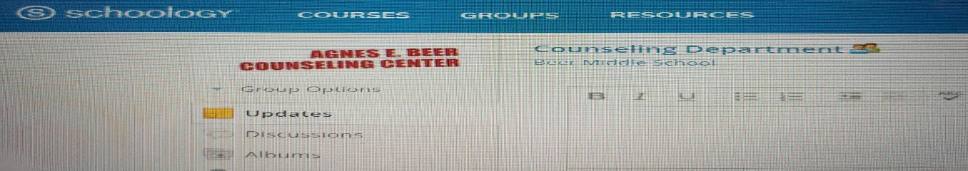
Directions on how to join a conference in our Schoology group: https://www.youtube.com/watch?v=vbQ6mgW0mbQ

Ms. Hill
Counselor for Students with the Last Names: A-Khalil
Email: bhill@wcskids.net
Office Phone Number: 586-698-4279
Google Phone Number: 586-244-8549
Office Hours: https://wcskids.webex.com/meet/bhill
Website: http://beermiddleschoolcounseling.weebly.com/ms-hill.html

Mr. Kay
Counselor for Students with the Last Names: Kham-Z
Email: rkay@wcskids.net
Office Phone Number: 586-698-4280
Google Phone Number: 810-844-1360
Office Hours: https://wcskids.webex.com/meet/rkay
Website: http://beermiddleschoolcounseling.weebly.com/mr-kay.html

Ms. Jaworski
School Psychologist
Email: kjaworski@wcskids.net
Office Phone Number (Beer MS): 586-698-6507
Google Phone Number: 586-335-2998
Office Hours: https://wcskids.webex.com/meet/kjaworski
Website: https://wcscovidcopingsupport.weebly.com/

Mrs. McEvoy
School Social Worker
Email: mmcevoy@wcskids.net
Office Phone Number (Beer MS): 586-698-4489
Office Hours: https://wcskids.webex.com/meet/mmcevoy

Counseling Website: http://beermiddleschoolcounseling.weebly.com/

