CREATING A PARENT PORTAL LOGIN

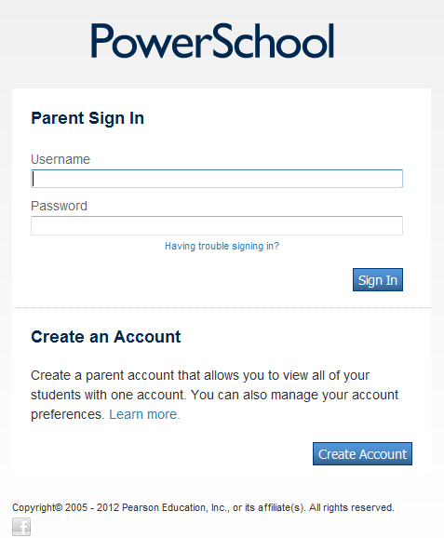
If you have created your own account, but forgot the username/password, click here.
If you have the Access ID and Password, but have not created your own account, click here.
If you have already created your own login & password – login here

CREATE A PARENT ACCOUNT

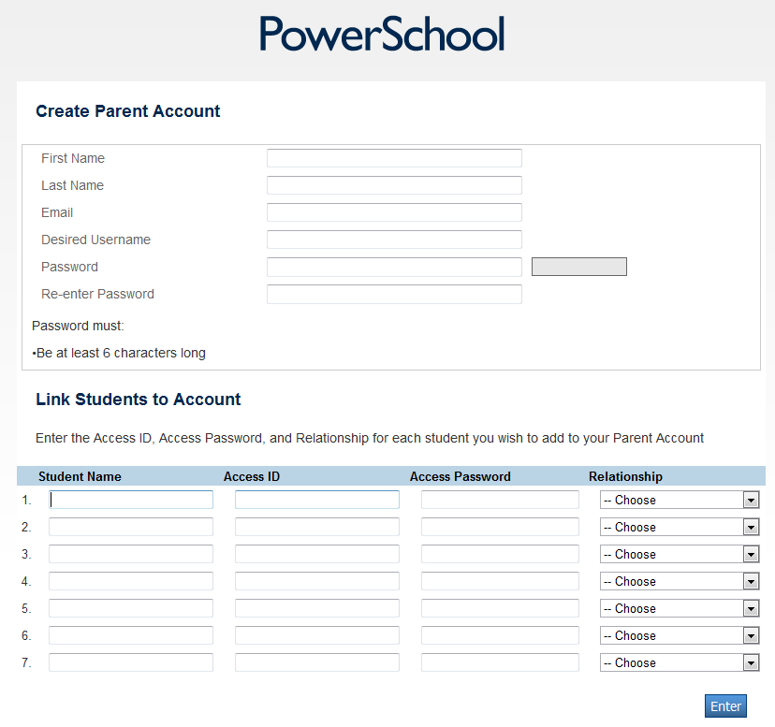
Your relationship to the student
MUST BE UPPERCASE LETTERS
Sample: XP2TG3
Sample: P123456
First & Last Name
Retype Password
Password – Cannot match student or parent name
Unique Username
Parent Email Address

Parent Last Name
Parent First Name

