Getting Students Prepared for Xello (Formerly known as Career Cruising)
Students Logging in
- Students will access Xello through our Office 365 single sign on platform. In the "waffle", students will go to All Apps to find Xello for the first time, once they use it Xello will remain in their Apps for future
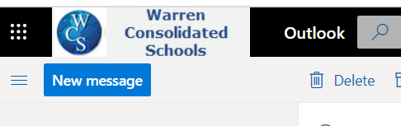
Once Students are Logged In

- Once logged in, then you will see this on your screen
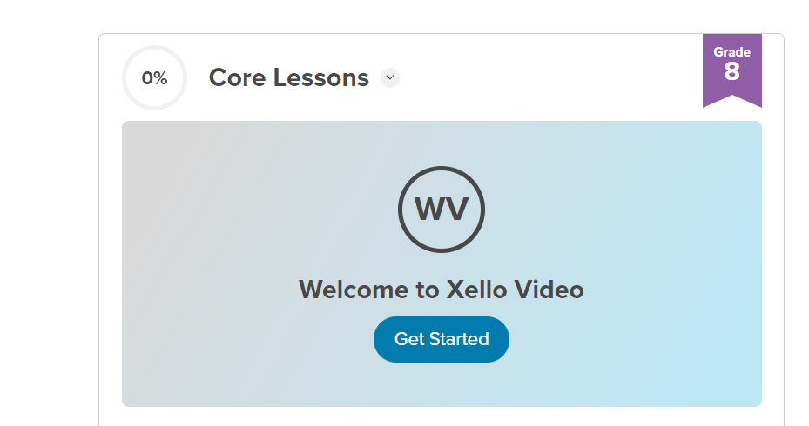
You must watch this video

https://www.youtube.com/watch?v=o5kZZOfcOAQ
2. Once you watch the video and you click done in the top right corner you will see this screen. Click on the 8th Grade EDP Lesson
You must complete all the activities in the 8th grade EDP lesson!
Step 3

Step2

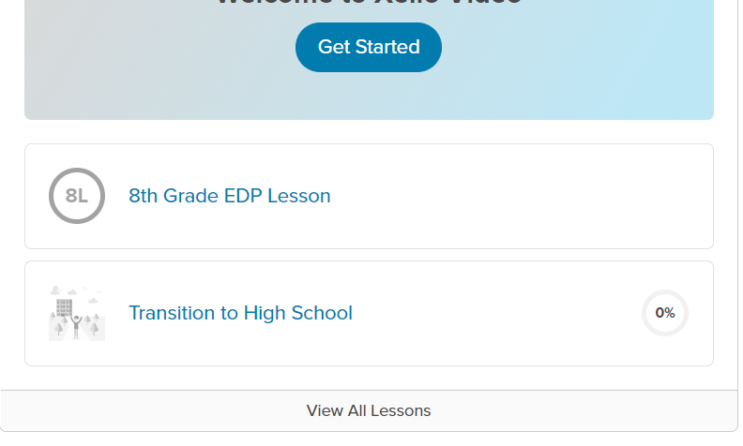

- Then you will then see this screen

8th Grade EDP Lesson
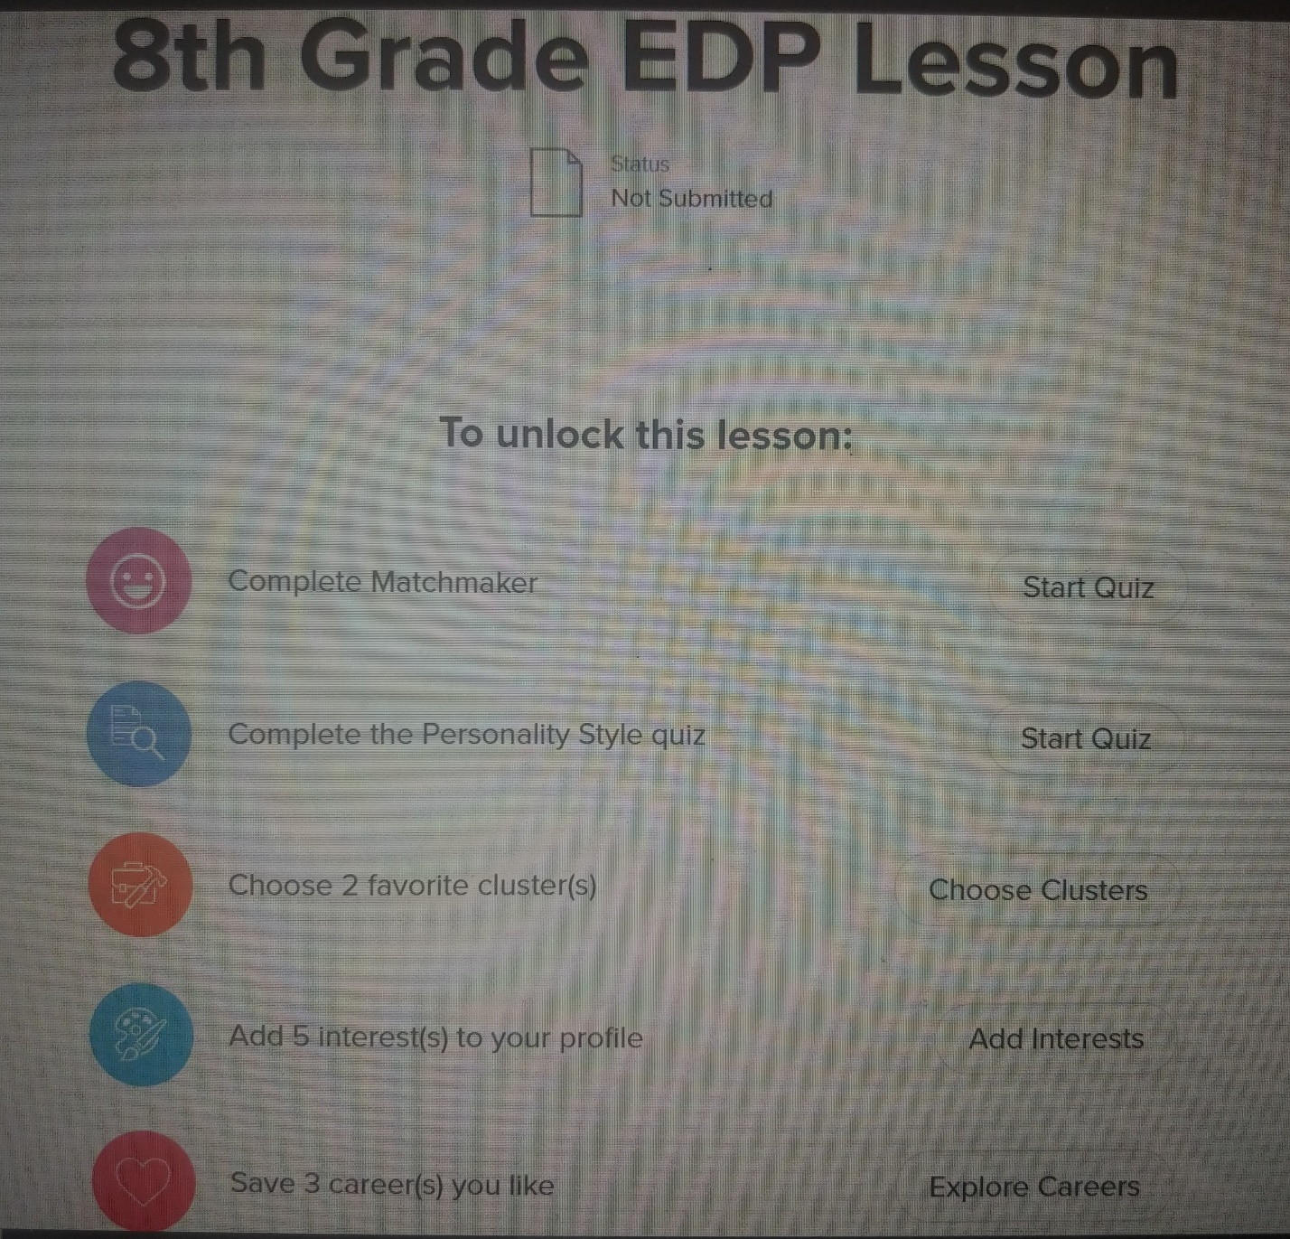

- How do I know if I’ve completed all that needs to be done?

Once you get to 100%

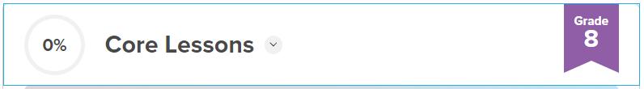

- What can I do once I’ve finished?
Explore and navigate the website. This is an amazing tool for you to use for exploration of careers, colleges, and more.
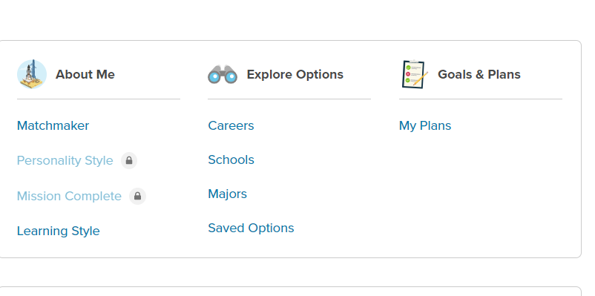
You can click on any of these options to explore further!

